Exploring the Relationship Between
Childcare Costs and Workforce Participation
in the United States
Research Questions and Answers

Vijay Sharma
Bellevue University
DSC 680: Applied Data Science
Instructor: Xu Ashton
August 21st 2026

Analysis Basis
Answers are based on 23,593 complete county-year observations from 2008–2018. Annual infant cost equals MCInfant × 52, and burden equals annual cost divided by MHI_2018. State values are population weighted.

Question 1
How do childcare costs influence workforce participation rates across U.S. states?
Childcare burden showed only a small uncontrolled county-year relationship with participation (r = -0.041). In the adjusted robust regression, burden was not significant (b = 0.015, 95% CI [-0.026, 0.055], p = 0.470). The evidence does not support a direct independent effect in these aggregate data.

Question 2
Which states experience the highest childcare affordability burden?
For 2018, the highest estimated burdens were New York (27.0%), Massachusetts (25.3%), California (23.8%), Hawaii (21.7%), Minnesota (21.4%), Wisconsin (21.3%), Connecticut (21.1%), Ohio (21.0%), Washington (20.8%), and Illinois (20.6%).

Question 3
What relationship exists between childcare costs and median household income?
Costs and income moved together strongly at the state-year level (r = 0.753, p < .001). Higher-income areas generally had higher childcare prices, so affordability must be evaluated as a ratio of cost to income.

Question 4
Do higher childcare costs correspond with lower labor-force participation rates?
Not after adjustment. Although the county-level bivariate correlation was slightly negative, the adjusted burden coefficient was 0.015 and nonsignificant (p = 0.470). Therefore, the hypothesis of a consistent lower participation rate at higher burden was not supported.

Question 5
Are there regional differences in childcare affordability?
Yes. Mean burden differed by region in 2018, F = 3.44, p = 0.027. Mean burden was highest in the Northeast (20.4%) and lowest in the South (15.7%).

Question 6
How have childcare costs changed over time?
Average annual center-based infant cost increased from $8,694 in 2008 to $11,195 in 2018, a 28.8% increase and 2.6% compound annual growth. Average burden rose from 14.3% to 17.8%.

Top 10 State Results, 2018
State | Annual cost | Burden | Participation
New York | $17,382 | 27.0% | 72.4%
Massachusetts | $19,703 | 25.3% | 77.3%
California | $17,025 | 23.8% | 67.2%
Hawaii | $18,000 | 21.7% | 64.5%
Minnesota | $15,088 | 21.4% | 80.6%
Wisconsin | $12,549 | 21.3% | 78.9%
Connecticut | $16,291 | 21.1% | 75.3%
Ohio | $11,454 | 21.0% | 75.1%
Washington | $14,926 | 20.8% | 65.1%
Illinois | $13,281 | 20.6% | 73.7%
Figure 1
Summary of Major Findings
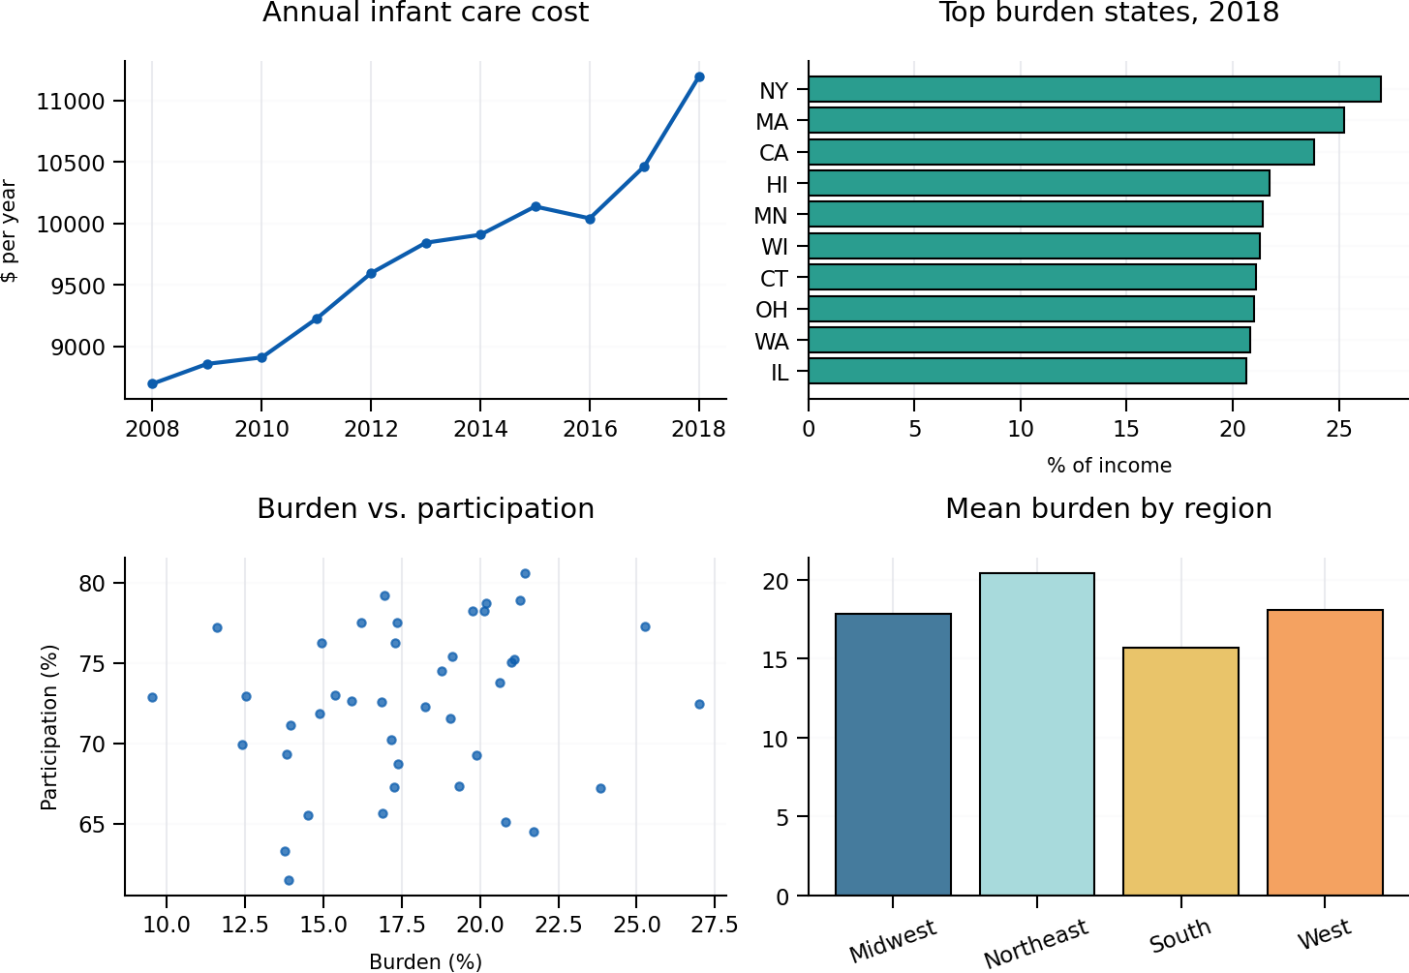
Note. All estimates are derived from the submitted National Database of Childcare Prices file.

Interpretation Note
These answers describe association, not causation. Aggregate state and county values cannot identify individual family decisions, and the 2018 ranking includes only states or districts with complete analytical data.

